City and Guilds
ITQ
Web Design

Contents
Contents 2
Website Software Level 2 (4 credits) 3
Shackleton - Web Page 3
Pyramids - CSS Intro 4
Pyramids - CSS Intro 4
Shackleton (Styles) 5
Task: Shackleton (Layout) 6
Task: Pyramids (Further CSS) 8
Task: Shackleton (Classes) 9
Task: Buttons (javascript) 10
Task: Adding Text (javascript) 10
Task: inputting value (javascript) 10

Website Software Level 2 (4 credits)

Shackleton - Web Page
Step 1: Navigate to the WebDesign folder and look inside the Shackleton folder. Open the text file index.html in either Notepad or Wordpad. You will see that some html, head and body tags have already been put in for you.
Step 2: Use the <title> tag (and remember to close it) so that the text “Ernest Shackleton” appears in the title bar.
Step 3: Use the <h2> tag to put the first line of text “Sir Ernest Shackleton (1874 – 1922) as a heading.
Step 4: Now insert the picture “shackletonicon.jpg” using the <img> tag straight after the heading. The jpg file is in the folder imgs so you will need to make sure your file path for the picture reflects this.
Step 5: The next 5 lines is a list of sub topics for our site. So create an ordered (numbered by default) list with these 5 lines as elements.
Step 6: Use the <p> tag to create a paragraph using the text which starts “Sir Ernest Shackleton ...” and finishes Imperial Trans-Antarctic expedition”
Step 7: Put the next line of text “Shackleton’s Life as an <h2> heading.
Step 8: Convert the first three words of the first paragraph “Sir Ernest Shackleton” into a link which takes the reader to the Wikipedia page on Ernest Shackleton.
Step 9: Copy your html text and paste it into the Marking Engine.

Pyramids - CSS Intro
Step 1: Open the html file pyramid.html. This contains html which you should look at and make sure you understand what all the tags are doing.
Step 2: In the style folder, look at the style sheet called pyram.css.
Step 3: In the html note that the div tag embraces the heading and the paragraph text. In your style sheet format the identity selector main so that the background colour is #FFCC73.
Step 4: Using CSS set the style of the paragraph <p> to Arial, colour black and font size 14pt. Try looking up the hex value of black and using that (this will give you more control later).
Step 5: Now format heading 1 (i.e. selector h1) so that the font is Castellar (and as a back-up font to default to Arial). Set the weight to 700, the text colour to white and the background-colour to #A66A00.
Step 6: Now try using the <span> </span> tags so that the text “Pyramids” of the heading has background sandy - #A66A00. (Hint: Apply a newly created class selector called sandyback to the span tag so you can set the class to a sandy background in the pyram.css file and remove the background colour from the h1 tag).
Step 7: Try experimenting with some more colour schemes. The site http://colorschemedesigner.com/ will help you do this.

Shackleton (Styles)
Step 1: Create a folder called style and create a file called style.css which will be your stylesheet.
Step 2: Connect the stylesheet to index.html using the <link> tag.
Step 3: Use CSS, change the background colour of the page (apply this to the <body> tag) to light blue (#ADD8E6), the font to Candara, font size to 12pt and font colour to #003399. Ask the css to revert to Arial if Candara is not available on the browser.
Step 4: Change the headings (h2 and h3) so that they have a solid, 1px bottom border of colour #0033CC. Also change h2 to size 16pt and h3 to 14pt.
Step 5: Turn the text in your list into hyperlinks to other pages on the site as follows
- Introduction – index.html
- Dulwich College – dc.html
- Nimrod Expedition – Nimrod.html;
- Endurance – endurance.html;
- Rowlett – Rowlett.html
Step 6: Save both the style sheet and the html page. Your page should look like the screenshot below:
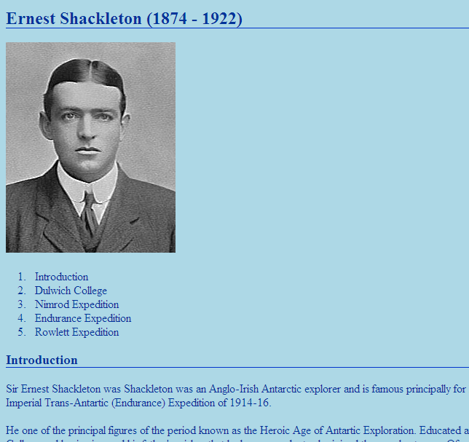

Shackleton - Layout
Step 1: Open your index.html and main.css files. What we need to do next is design our main page layout. Because we want our whole website to be consistent this will be the basis for all our pages.
We are going to aim for the following layout which has a header, two columns (nav and container) and, eventually, a footer, all of which are wrapped in the wrapper. All of these divs are identities not classes.
body
wrapper
footer
nav
container
header
Step 2: Start by putting in the wrapper div and then put the heading and picture in a header section.
Step 3: Now the list of links into a nav div section and the main text in a container section. (Do not worry about the footer for the moment!). Also remember to comment your html so that you know which tag the closing tag is paired with.
Step 4: Use CSS to centre the wrapper section, give it a width of 40em (use em so it re-sizes properly) and has a 5px padding.
Step 5: Use CSS on the header div so that it is of fixed height of 75px and has a dotted bottom border of width 2px and colour #B2BCC6. Now make the image 70px high, floated to the left and so that the h2 text is to the right and not too close to the top of the header section. [Advanced: You may also like to put a white shimmer on the top of h2 text in the header by using the text shadow function to give the impression of snow-capped mountains]
Step 6: Use CSS to position the nav (width 16em) and container (width 23em) divs side by side.

Pyramids - Further CSS
Return to the pyramids.html and pyram.css files. Now try to create your own layout for this website. Here are some suggestions:
- Research a bit more about Pyramids.
- The site is for children aged around 11 years old so decide on a font and make sure you have backup fonts for different browsers.
- Sketch a layout/page design for the material you have – remember to have navigation links and put the material into sections.
- Insert suitable pictures.
- Try to use identities and classes appropriately.
- Put acknowledgments in the footer

Shackleton - Classes
Step 1: You will have noticed if you are viewing your webpage in Firefox that by introducing the columns the background has disappeared. This is because the length of them is unknown. So put in a new div which has the class clearme and set the CSS for clearme to clear the floats. Your colour should return.
Step 2: Now add a footer section at the bottom of the page which says something like “Thank you for visiting my webpage”. Put a border at the top of the footer which mirrors the grey border at the bottom of the header.
Step 3: Now produce a class called snippet. Use CSS so the snippet has a 1px solid border on the left hand side with colour 003399 and put the text 5px away from the border. Apply this class to each of the paragraphs in the container.
Step 4: Use a class called myquote and the <span> tag to put the quote in paragraph 2 into italics.

JavaScript and HTML - Buttons
Step 1: In the file text.html write in the #button div section some html script which will put a button on the page.
Step 2: Define a JavaScript function called popup(). This function should put an alert on the screen with your name in it.
Step 3: Put code into the button tag which will run the function popup() when you click on the button.

JavaScript and HTML – Add text
Step 1: Alter the text.html file so that the button now runs a function called addtext().
Step 2: Define the JavaScript function addtext. This function should declare the div #mytext as an object. It should then alter that object so that the HTML inside the tag is “Hello there” and the text is blue (user the innerHTML and style.color methods on the object)

JavaScript and HTML – Input values
Step 1: Add a textbox (input) with id #myinput just before the button.
Step 2: Display the text in the input box in the #mytext div.
Step 3: If there is no text then pop up an alert to tell the user and then do nothing.

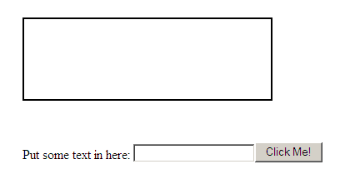

Remember the image must come before the text of the heading otherwise it won’t appear on the left so swap your html around

